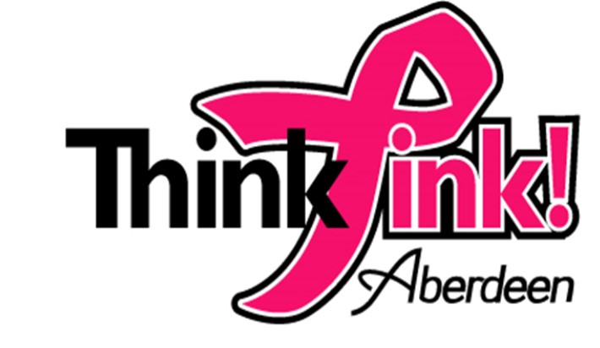
Must Reply by September 30, 2020

Sponsorship Levels: By checking a box below you will be Donating the following amount to “Think Pink Aberdeen MD”

Pink Diamond Level: $1000.00, Large logo on Pink Banners, our website and Facebook and Pink Ribbon window design and car cling

Pink Sapphire Level: $500.00 Medium logo on Pink Banners, our website and Facebook. Pink Ribbon window design and car cling

Pink Pearl Level: $250.00 Small logo on our website and Facebook. Pink Ribbon window design and car cling

Pink Quartz Level: $100.00 Website and Facebook acknowledgement, Pink Ribbon
window design, and car cling

Pink Ribbon Level: $50.00 Website and Facebook acknowledgement and car cling

Business Name: _______________________________________________________________
Contact Name: _______________________________________________________________
Preferred Email Address:_______________________________________________________
Preferred Phone Number: ______________________________________________________
Mailing Address: _____________________________________________________________
City _______________________________ State_______________ Zip_________________

For those who to prefer to just donate, please complete the following:
Contact Name: _______________________________________________________________
Preferred Email Address:_______________________________________________________
Preferred Phone Number: ______________________________________________________
Mailing Address: _____________________________________________________________
City _______________________________ State_______________ Zip_________________
Please make checks payable to: “Think Pink Aberdeen Md” Tax ID: 52-11398507
Mail form and check to: Think Pink Aberdeen MD
c/o Aberdeen Chamber of Commerce
18 N. Howard St. Aberdeen, Md. 21001
For more information visit us at: www.thinkpinkaberdeenmd.org or Facebook at thinkpinkaberdeenmd

